SECTION ONE
Alaminos Beach to Lefkara Reservoir checkpoint
30km, elevation gain: 714m
Start at the water’s edge on the sandy beach at Alaminos. (below)
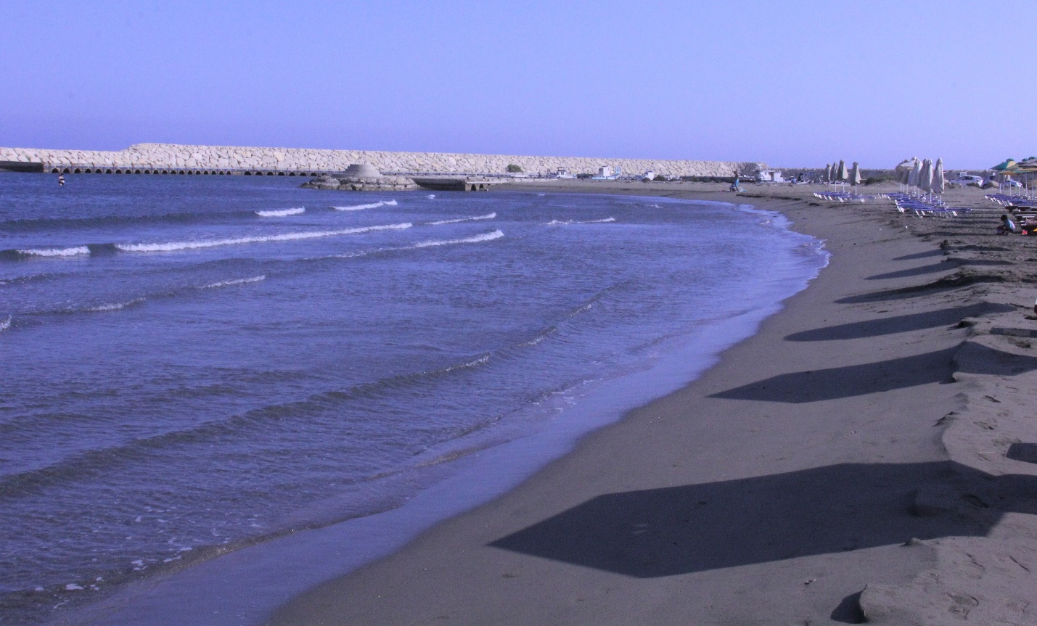

Head up the jeep track to the tarmac road. Turn left and after about 50 meters turn right onto the tarmac road that heads towards Alaminos village. After about 150m take the track veering to the left off the road, up an embankment and onto a rocky track.
Because the next kilometre or so is rather tricky, we will mark it out with reflective tape.
At the intersection next to the unfinished little building, take the right fork (keep the unfinished building on your left). The track now meanders through the farmlands and is relatively flat. At about the 2.6km mark, the track reaches a larger jeep track. Turn right here (go past the crumbly old building on your left).
Follow this jeep track through the beautiful valley and past the farmsteads until the 6km mark (more or less). Veer off to the left along a short track that cuts alongside farmland. When you hit the jeep track again, take a left. At the next intersection, take the right fork and head up and up the hill, right to the very top where you will enjoy majestic views. Look back and you will see the seaside where you started.
It’s now downhill for about 1.5km, all the way into the picturesque village of Agios Theodoros.
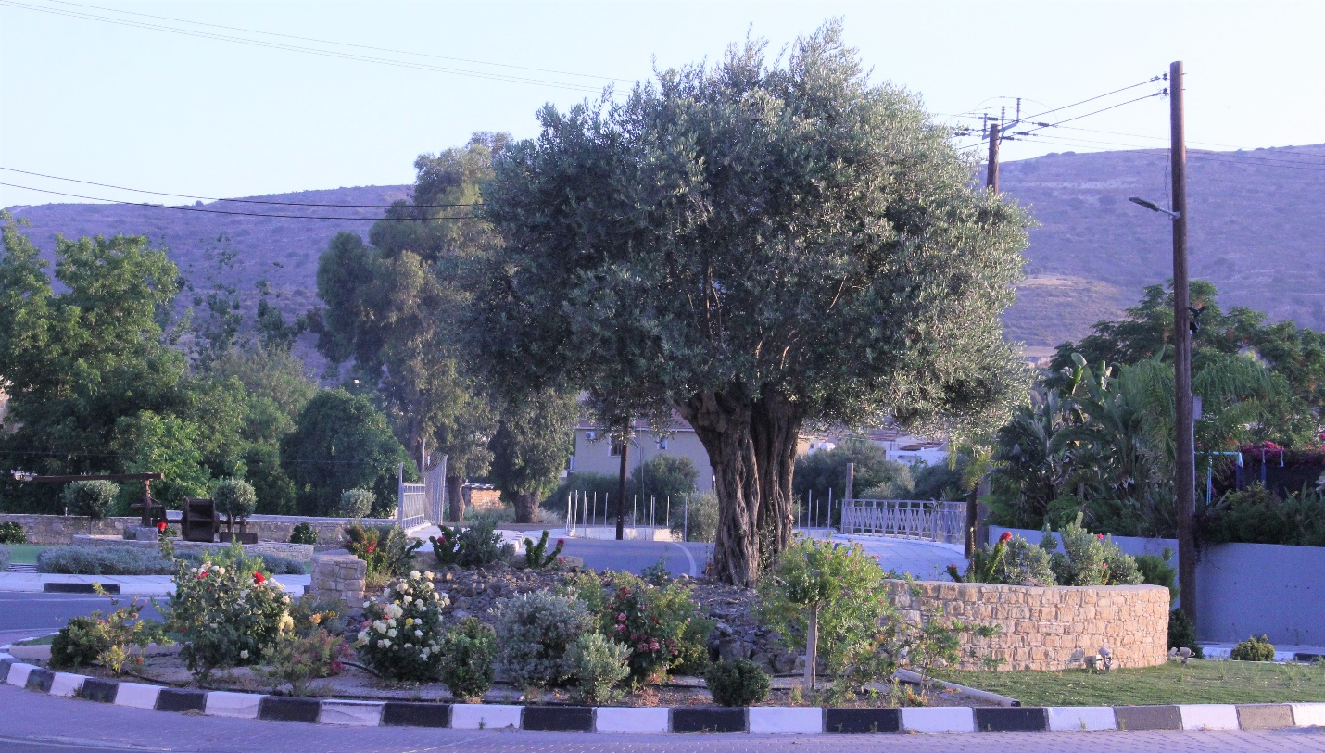
At the roundabout (pictured above), head up the hill (3 o’clock) along the tarmac road (keep to the wide pavements). Follow the road for about 3km to Skarinou, where the first checkpoint/aid station will be (opposite the aptly-named ‘Devotee Coffee Bar’ – pictured immediately below).
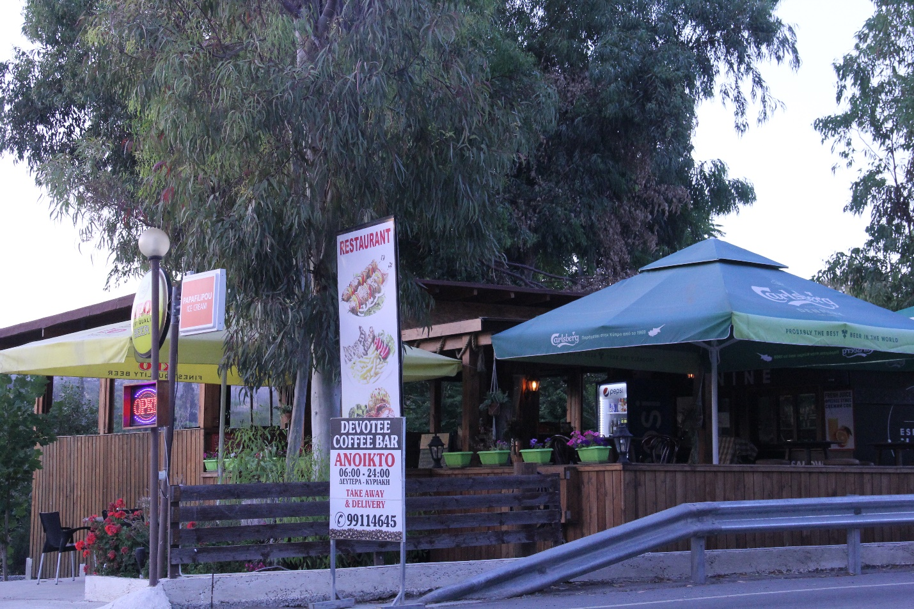
Now leave the main road and take the track that swings down sharply to the left and under the roadway. Follow this for 6km, passing under the motorway bridge high above. Very easy running from here along a partly paved road. At the intersection about 3km from the Skarinou checkpoint (16km from the start) turn RIGHT, and then a few hundred metres on, turn LEFT onto the road that will take you to the Dipotamos dam (pictured below).
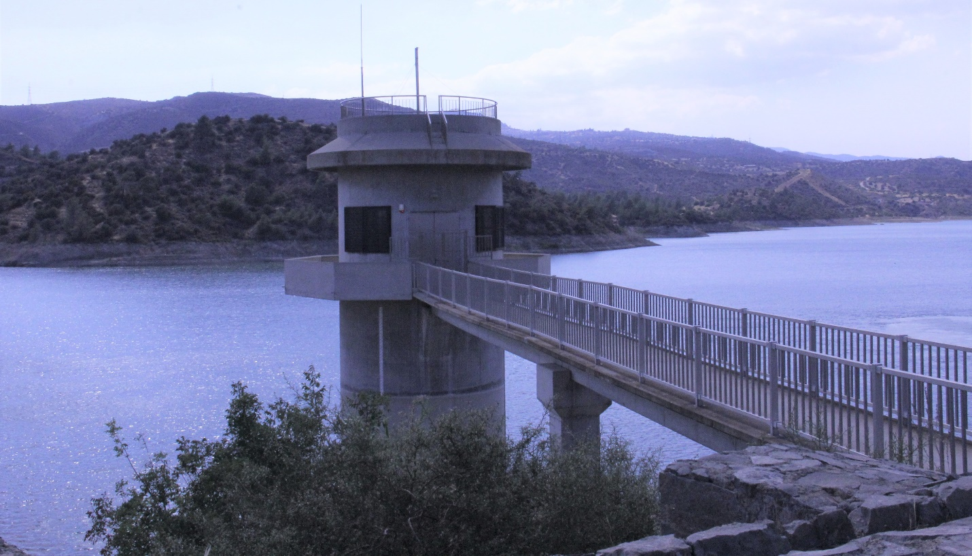

Cross the wall (not the one in the picture) to the other side and continue to the jeep track. Turn right – uphill – here. The next 7km or so comprises undulating rough-in-places jeep track, still very runnable.
At the T-junction (about 24.5 km from the start), turn LEFT. At the multi-road junction about 500 meters along, take the road heading slightly downhill to the LEFT.
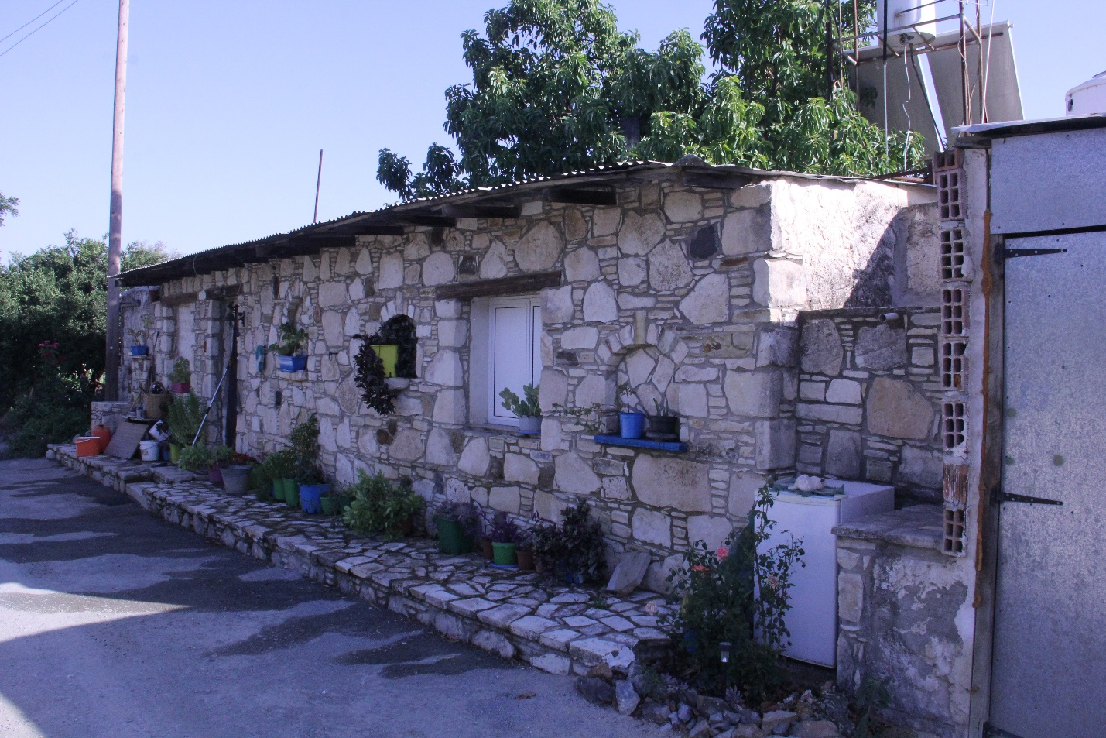
Go through a concrete-covered S-bend section of road. At the next intersection, go RIGHT and follow a very straight track that goes through farmsteads and includes some steep up and down roller coaster sections. Go past a beautiful farm cottage (pictured above).
At the intersection, cross the tarmac road and follow the track up to the Lefkara dam (pictured below) -- and the next big main checkpoint/feeding station.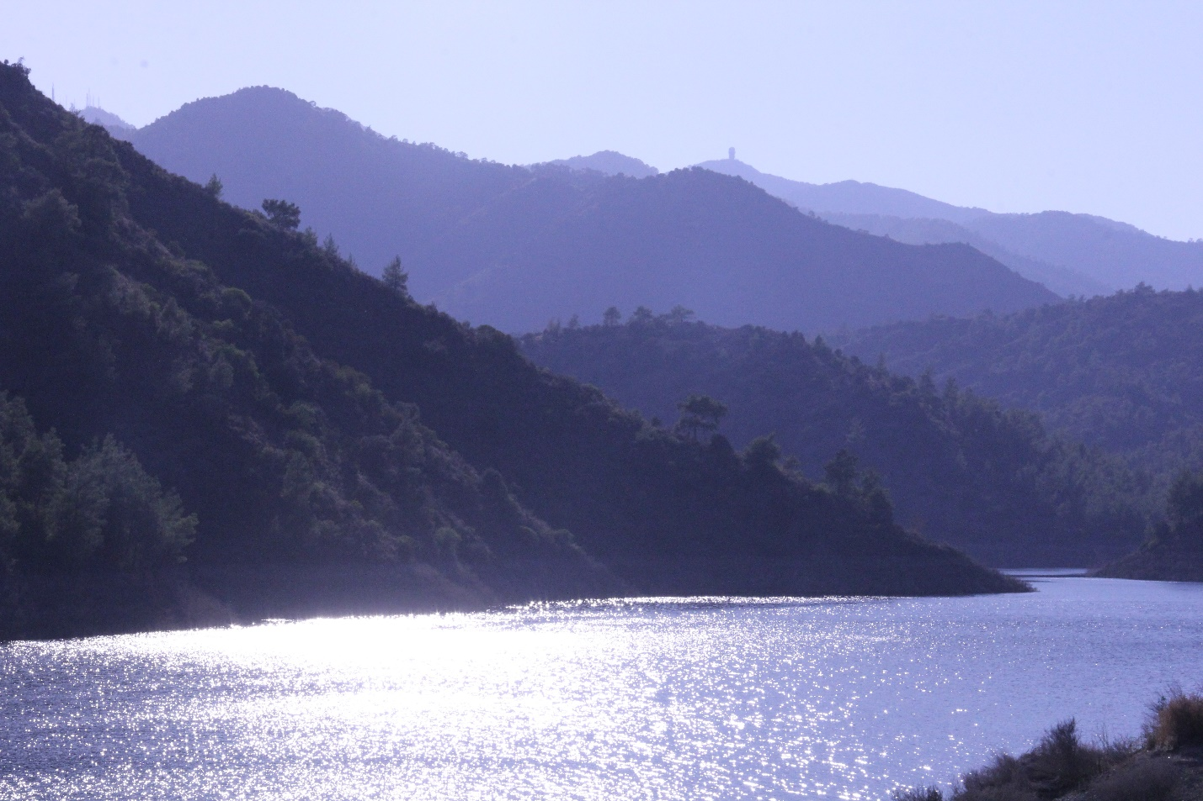

SECTION 2
Lefkara Reservoir to Kionia picnic site checkpoint
20km, Elevation gain: 1,303m

Leaving the checkpoint, you now follow the shores (from on-high) of the Lefkara reservoir, a very runnable section despite some short, sharp ups – counterbalanced by some long undulating downs.
At the T-junction, turn left. You will pass a deserted building – what remains of the abandoned settlement of Kypravasa .
Soon after you leave Kypravasa, you will reach a three-way junction. Take the right fork, going up the hill. Follow this track steadily upwards. There are several forks in the road, so keep a watch for the Sea-to-Sky markings (below) as well as reflective arrows.
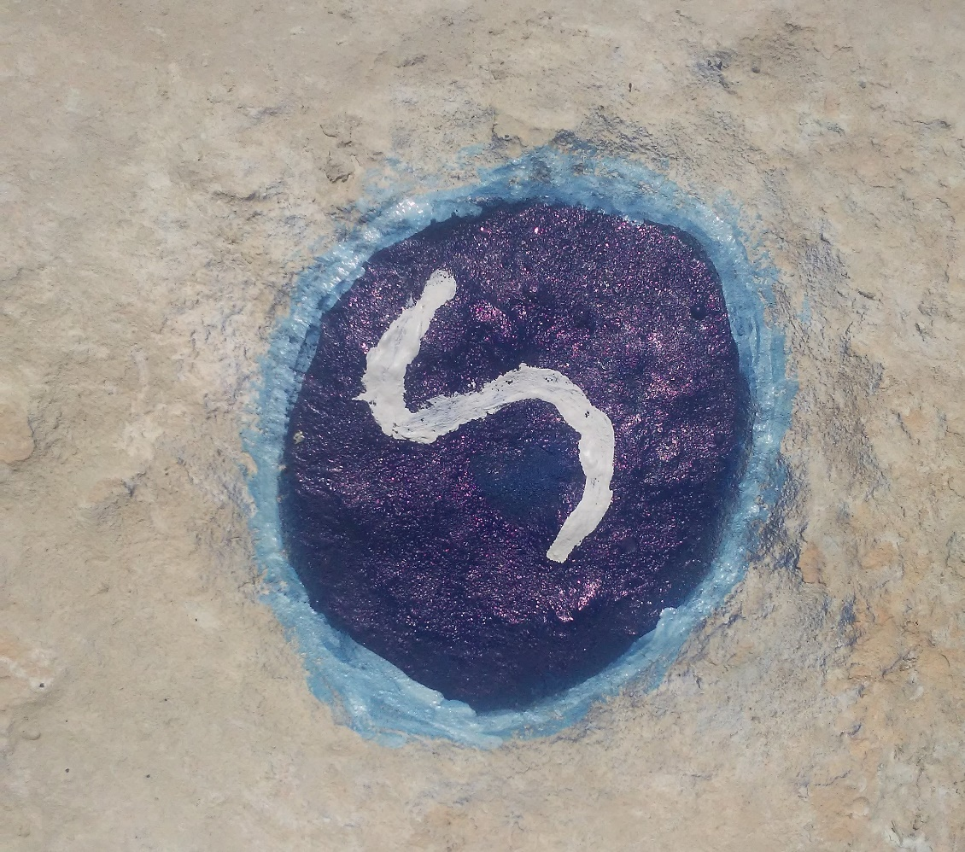

At about the 40km mark (from the start), if you detour briefly from the route at the intersection you will find the beautiful Vrisi water fountain (below). Replenish your water supplies here. Then head up the hill (water fountain on your left behind you).

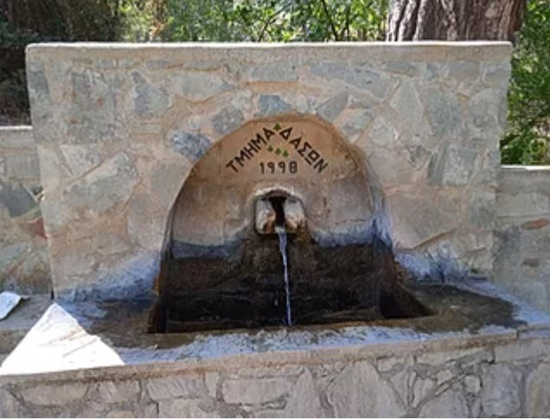
At the junction about 300 meters up the hill take the road off to the left (don’t follow the sign that points you to Profitis Elias – this a longer route to Kionia.)
Take the next right fork and soon after a sharp turnoff right up a hill. Follow the jeep track till you reach the E4 single-track hiking trail. Turn left onto the hiking trail and follow the E4 for about 6km until you get to the Kionia picnic area and the next checkpoint/aid station. There will be NO Sea-to-Sky markings on the public hiking trail. Follow the E4 signs.
SECTION 3
Kionia picnic site to Palaichori
30km elevation gain: 1163
In this section, runners follow the E4 hiking trail all the way from Kionia to the village of Fikardou (distance of about 24km). There are some Sea-to-Sky markings along the way to help runners when they leave and rejoin single-track trails for short stretches of connecting tarmac road, but runners should follow the E4 signs.
Leave the Kionia picnic site on the tarmac road. After about 200m, the E4 branches off to the right (on a different tarmac road).
Follow the road for about 1km. Turn onto the trail just before the boom gate (it is well marked – see picture below).
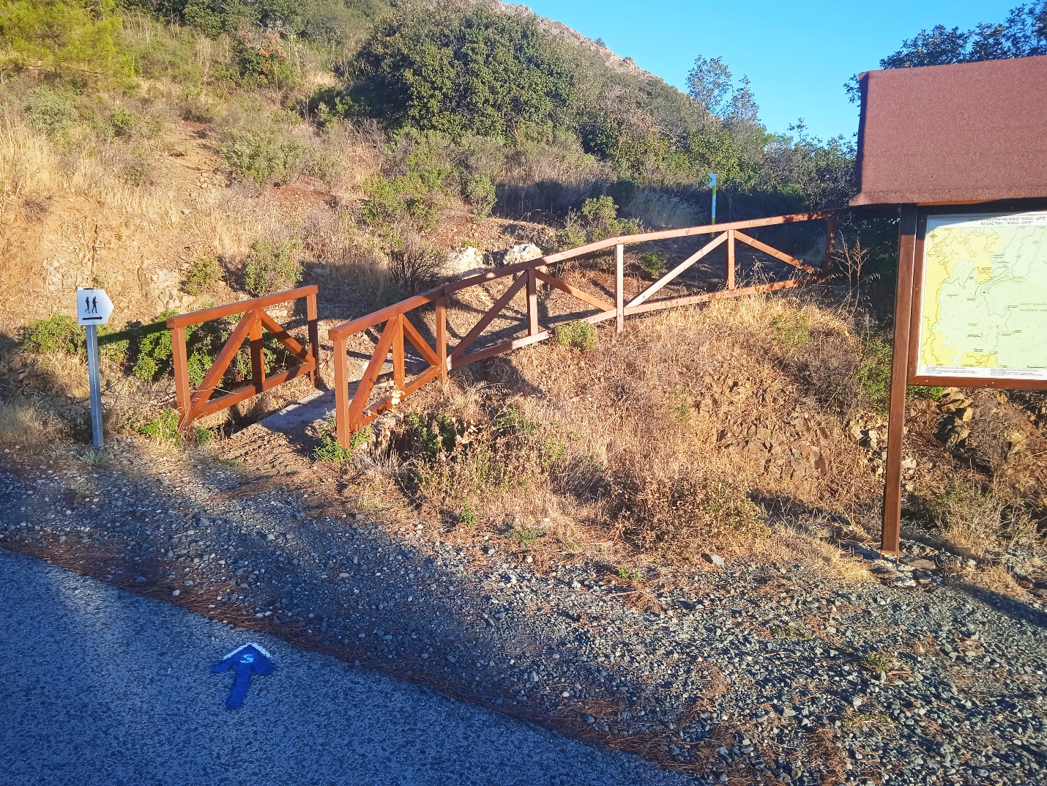

This next section is rather technical but by now it should be light. Watch your footing – there are railings and ropes in some of the trickier sections. There will be no Sea to Sky markings on this public hiking trail. Follow the E4 signs.
After about 4km, the single-track ends and runners follow the tarmac road down to the beautiful Machairas monastery (there is a tap at the small building after you pass the parking area of the monastery). Continue along the tarmac road for about 500m and find the signs leading you onto a single-track trail that dips down into the valley, crosses a river, and then heads up the hill to the picturesque village of Lazanias.
When you reach the tarmac road, turn right. Head up the hill, past a restaurant and a small yellow post office box (there is a water fountain here – see picture below).
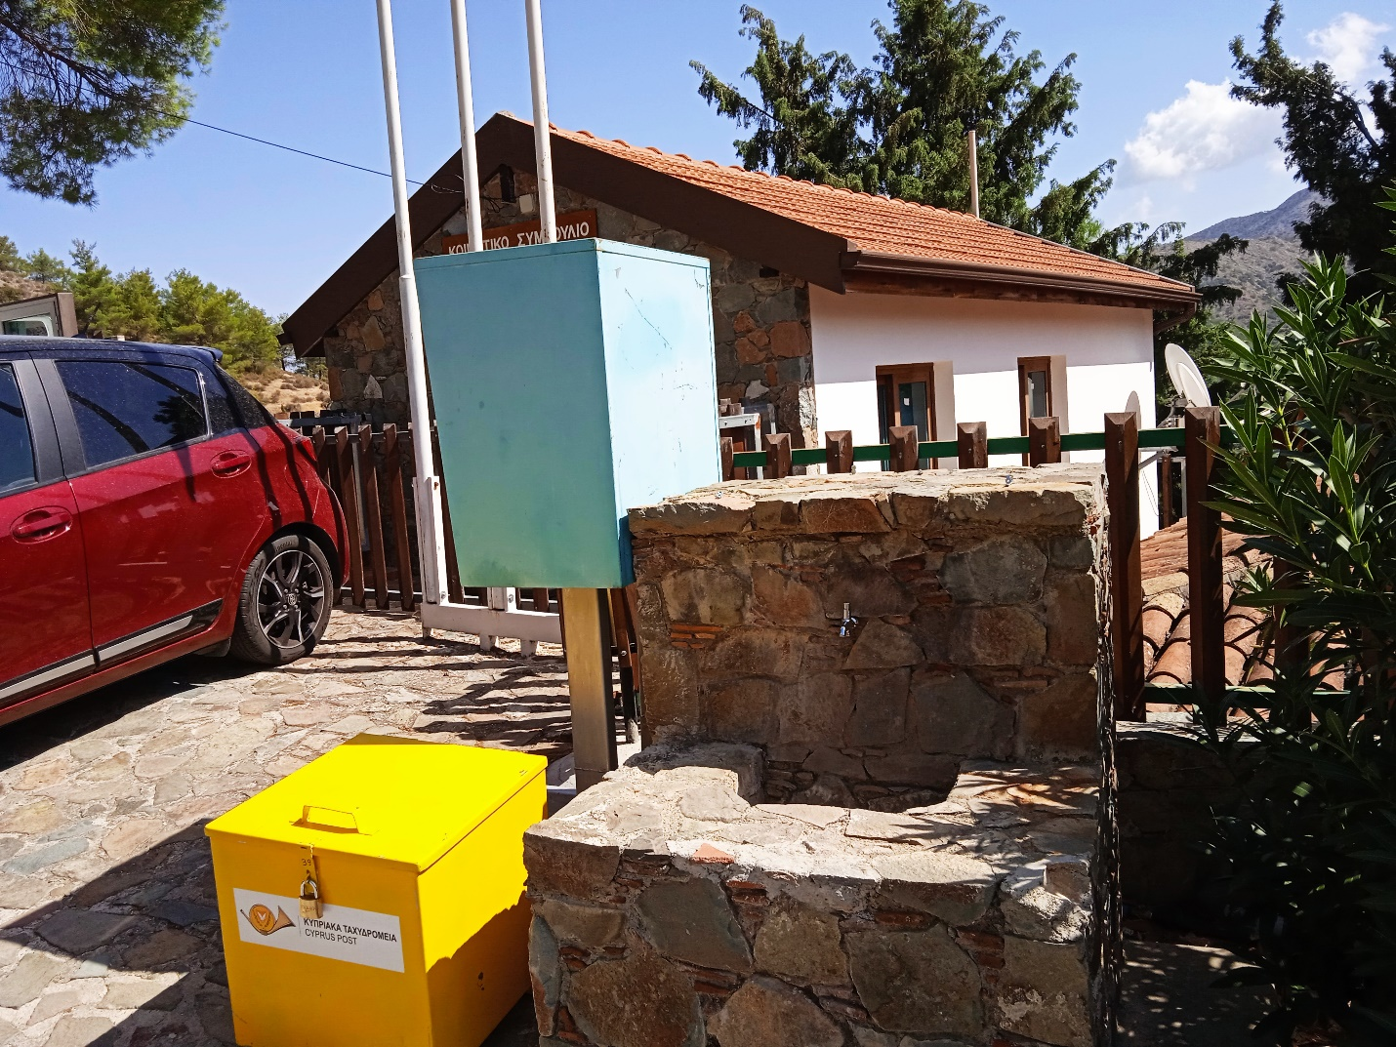

Follow the road up and out of the village. The trail to Fikardou begins after about 500m. Look for the boards and arrows pointing you off the tarmac onto a trail that winds steeply upwards to the crest of the hill. Be sure to take the sharp left onto the single-track trail. If you get to a water tower, you have missed the turn and need to go back.
From the top of the hill, the trail continues downwards to Fikardou. Turn left as you come off the trail and onto a jeep track that ends on a tarmac road.
It is here that runners leave the E4 and head towards the village of Gourri. Follow the Sea-to-Sky markings, which turn runners off onto a jeep track which winds through farmlands. Look for the DIY feeding station on a table on the verandah of Rebecca’s Restaurant (see picture below) soon after the jeep track ends and the tarmac begins.

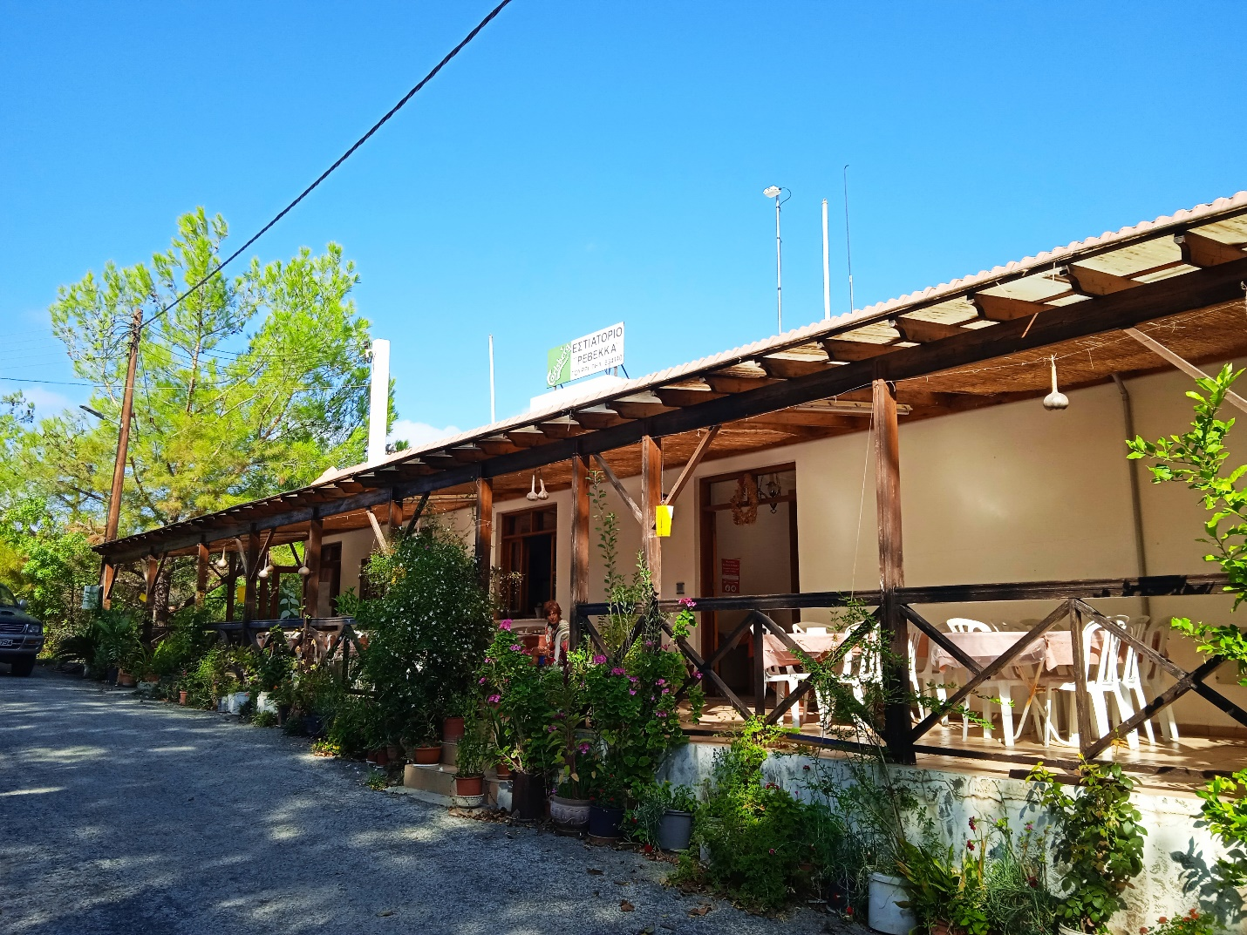
From Rebecca’s, the route follows a jeep track for about 1km and then goes off-piste down a ridge, which ends at the tarmac road. Cross the road and look for the arrows pointing you down into the valley.
Follow the Sea-to-Sky markings until you get to the E903. If you find you are on a horse-riding farm, watch out for the dogs and turn back until you find the right way.
Turn right when you get to the E903. There is now an unavoidable stretch of tarmac – be very vigilant, there could be lots of traffic.
Watch for the arrows turning you left off the E903. Under the fig tree you will find a DIY water point (water and Coke only). Follow the track up all the way to the beautiful Appis trail. Once on the trail, there will be no markings until it ends after 6km.
From the end of the trail, follow the markings into Palaichori. Turn right down the cobbled road next to the UNESCO church (pictured below) and go all the way down into the city centre. At the town square, turn left and up the hill to the Palaichori primary school, where the well-stocked Theopisti aid station will welcome you.
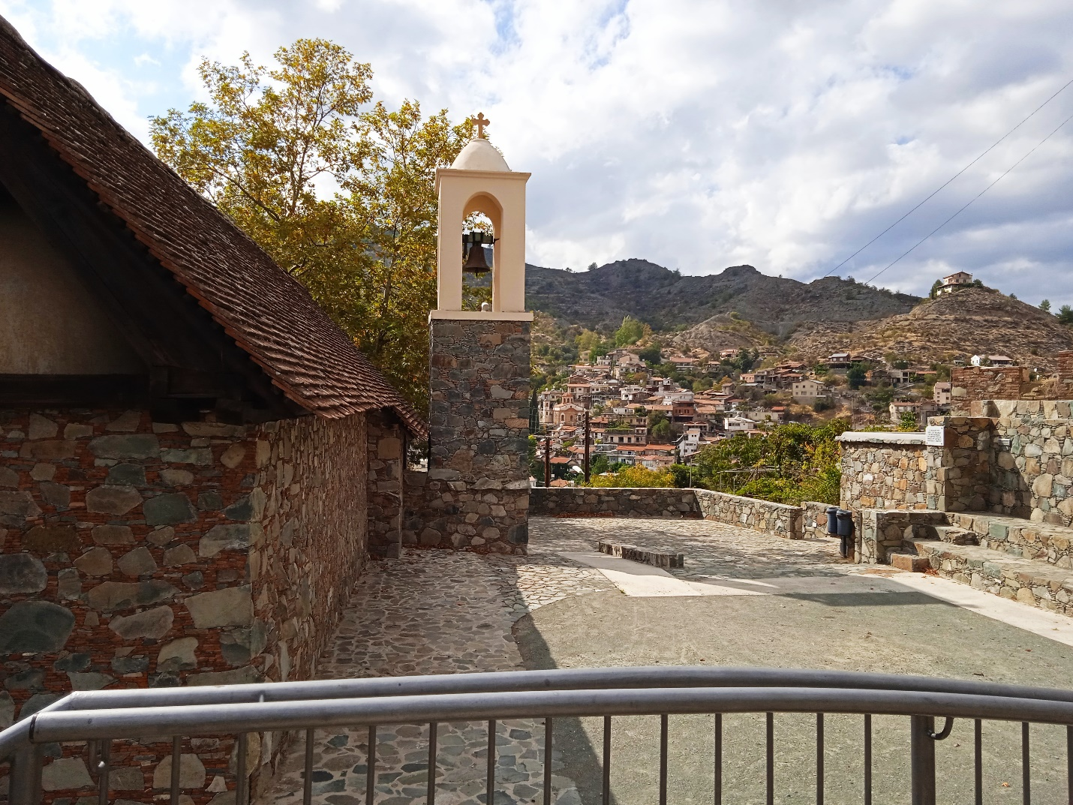

Runners tackling the Extreme Ultra must LEAVE this station by 5pm.

SECTION 4
Palaichori to Adventure Mountain Park
30km elevation gain: 1556m
Leave the checkpoint and turn left at the junction. Follow this tarmac road for about 800m. At the junction with the Nicosia-Agros main road turn left and then almost immediately turn right, crossing over and on to a small road.
You will now climb steadily upwards for about 7km – to the very top of Papoutsa peak (height 1538m – pictured below).

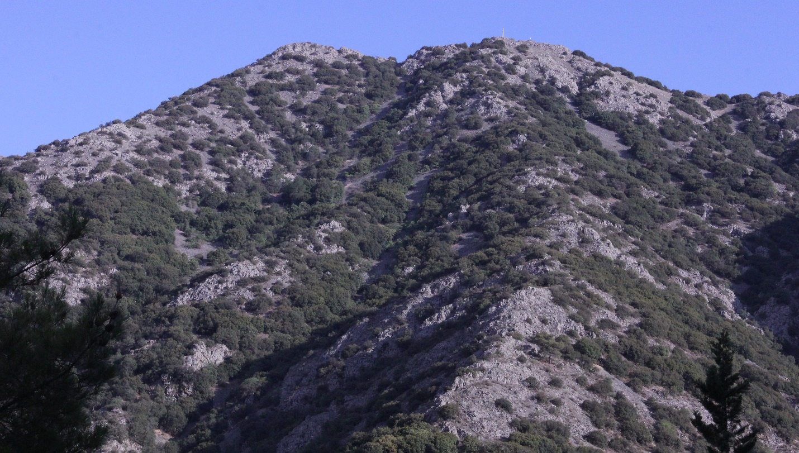
The first 5km is along very runnable jeep track. Look for the trailhead markings taking you off the jeep track on a single-track trail (picture below).

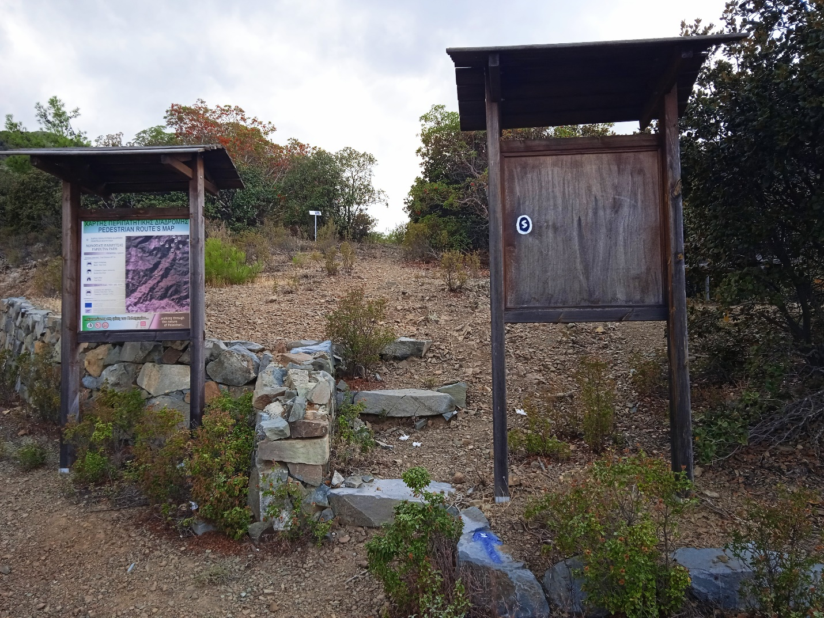

Follow the trail, which will take you to the base of Papoutsa. Follow the blue and white IcePower tape to the top and down the other side of the mountain. Note that Papoutsa has two peaks of about the same height. The first peak has a cairn on top (pictured below).

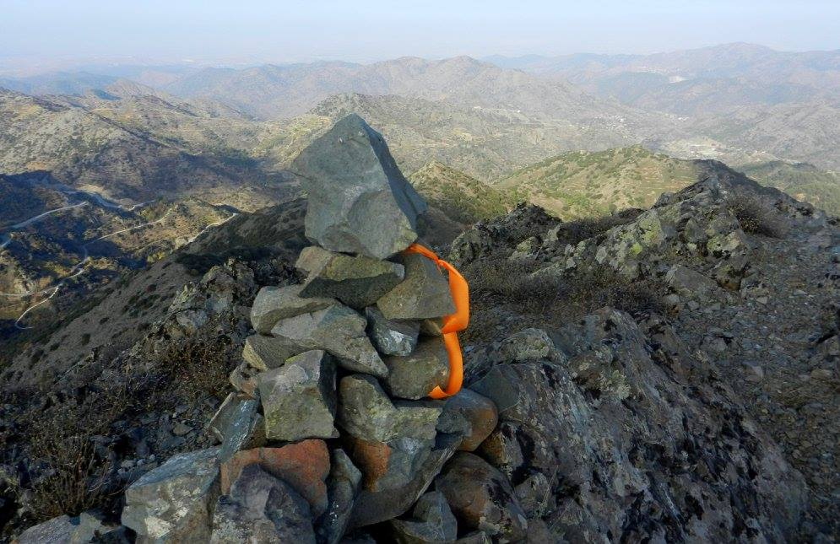

The second peak is marked by a huge cross and a shrine to the Mother Mary (below)

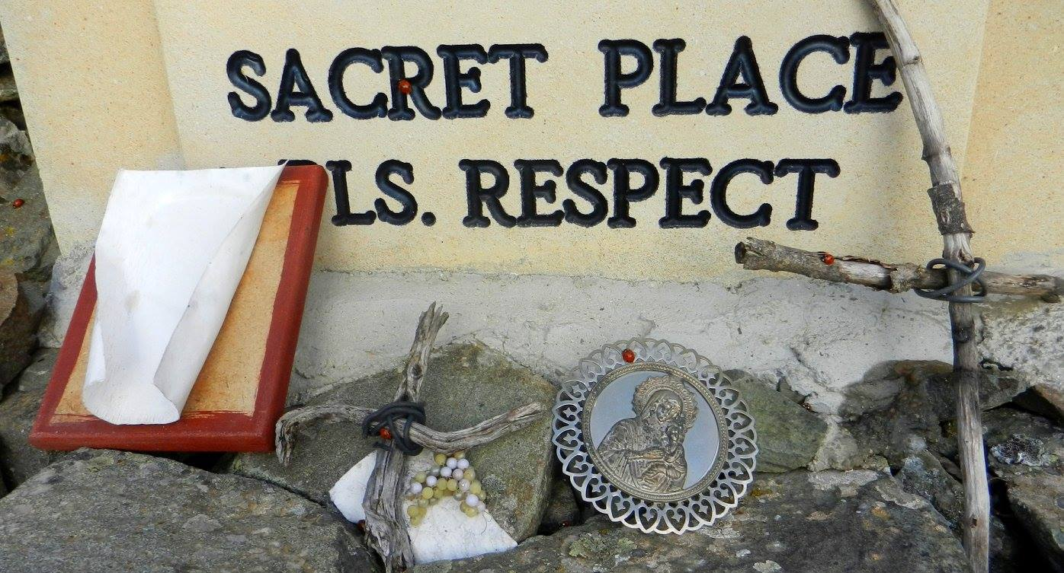
There are usually plenty of ladybirds mysteriously crawling around the shrine.
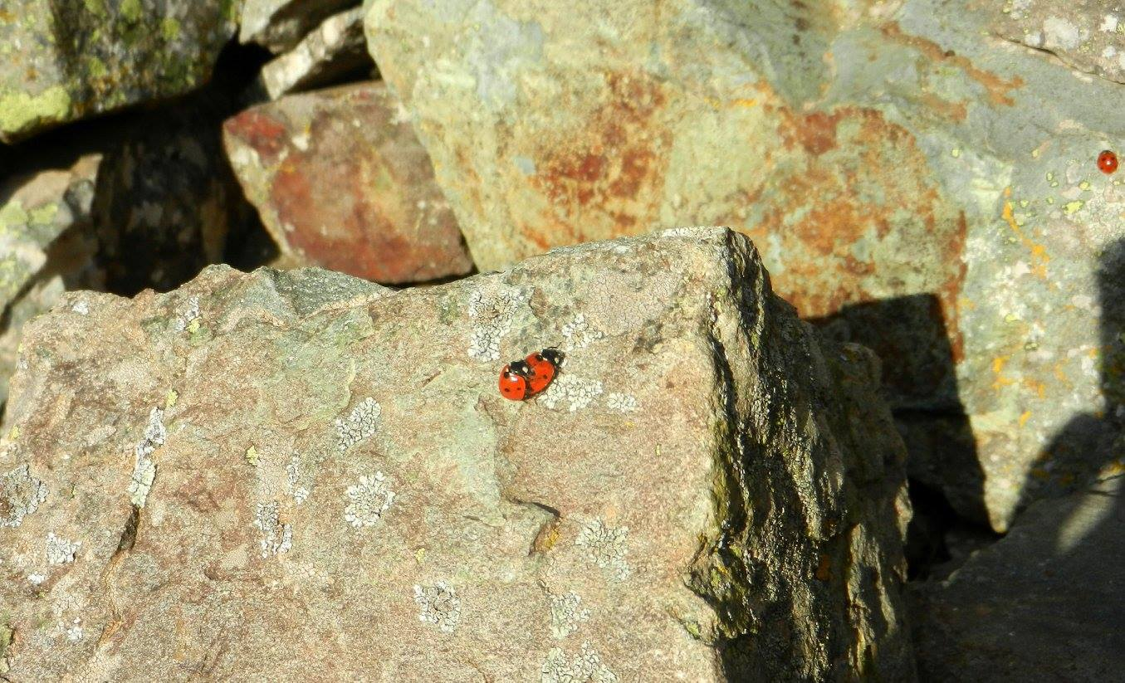
From the shrine, follow the tape down the trail on the other side of the mountain, to the picturesque village of Agios Theodoros. This trail has, unfortunately, been churned up by mountain bikers and the going is rather demanding. Take it easy and watch your footing.
The trail ends on a jeep track that leads to a tarmac road. Cross over and find the trail that skirts the village of Agios Theodoros (pictured below).
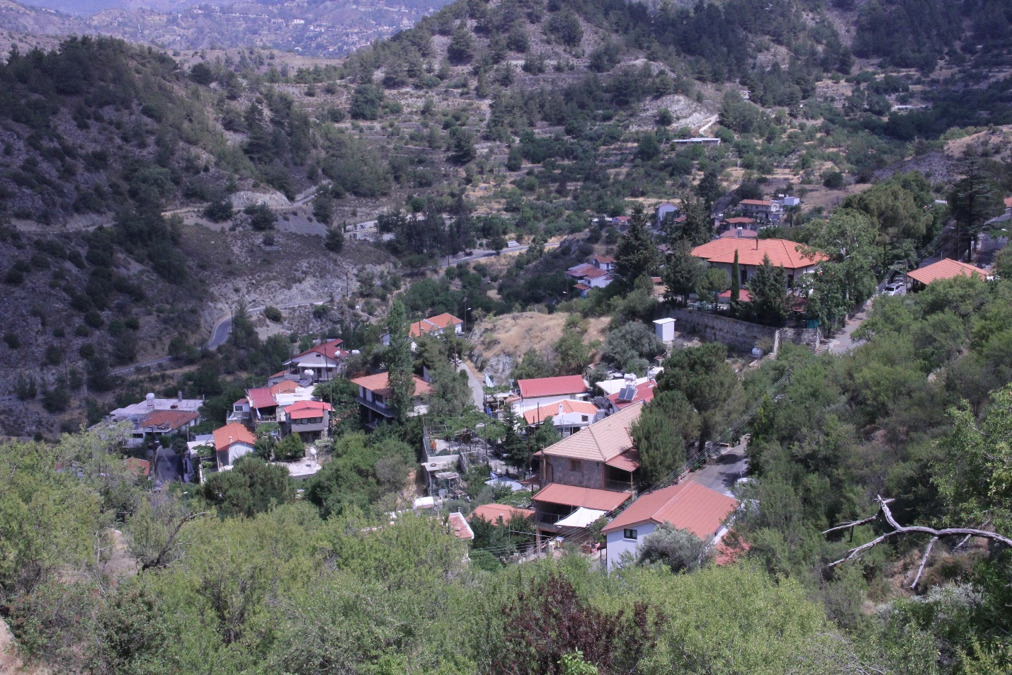

The trail leads to the adjoining beautiful village of Agios Ioannis (pictures below)

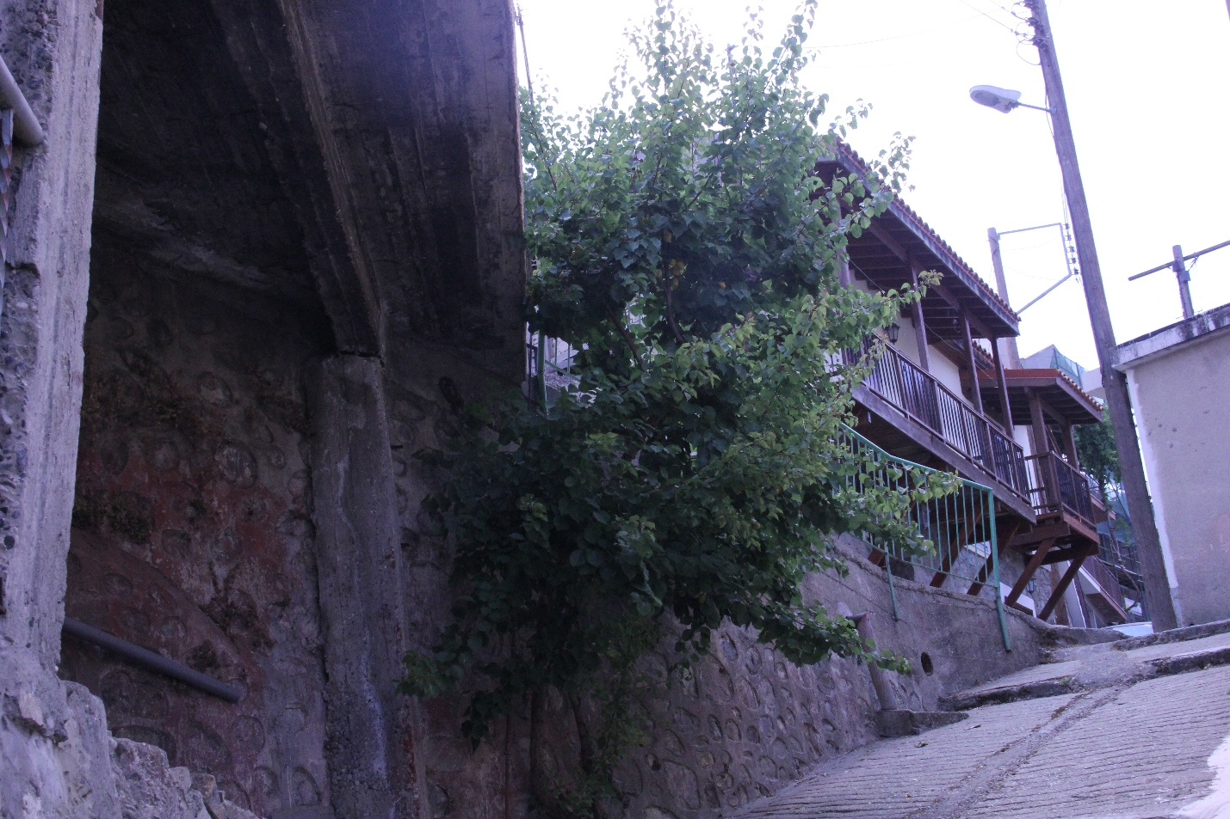
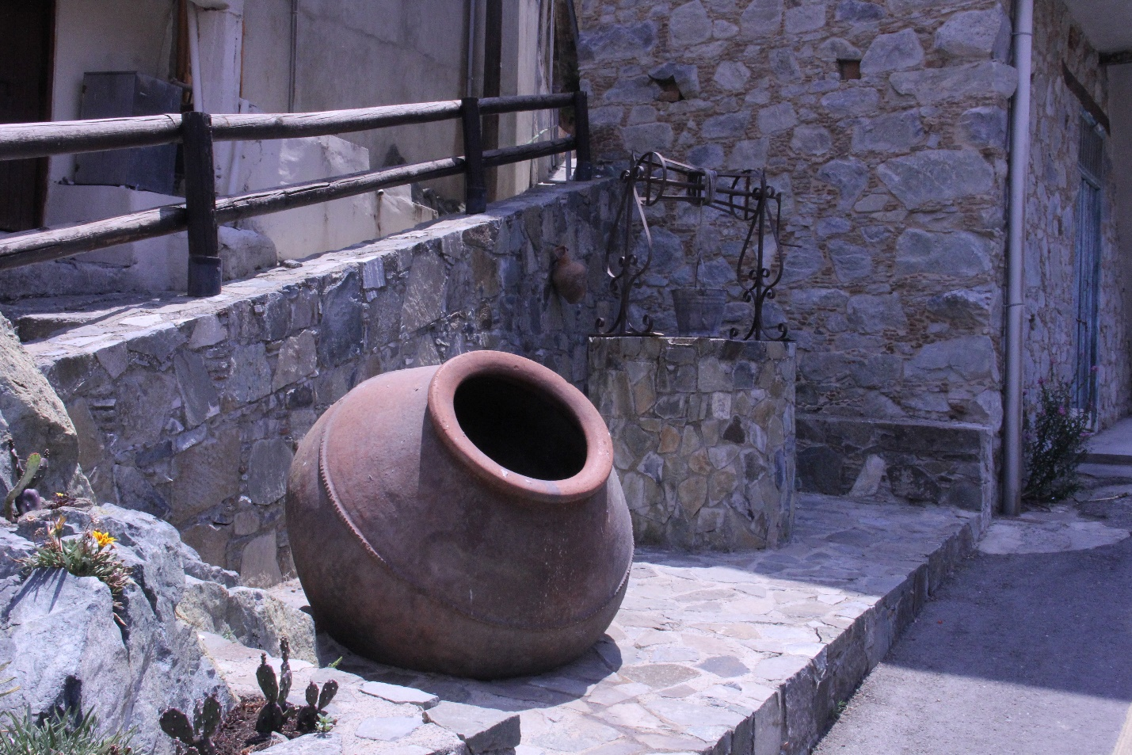
Follow the Sea-to-Sky markings for the short section that the route runs through the village and out the other side again.
There will be a DIY aid station at the big tree marking the start of another village trail (pictured below). There is also a water fountain here.
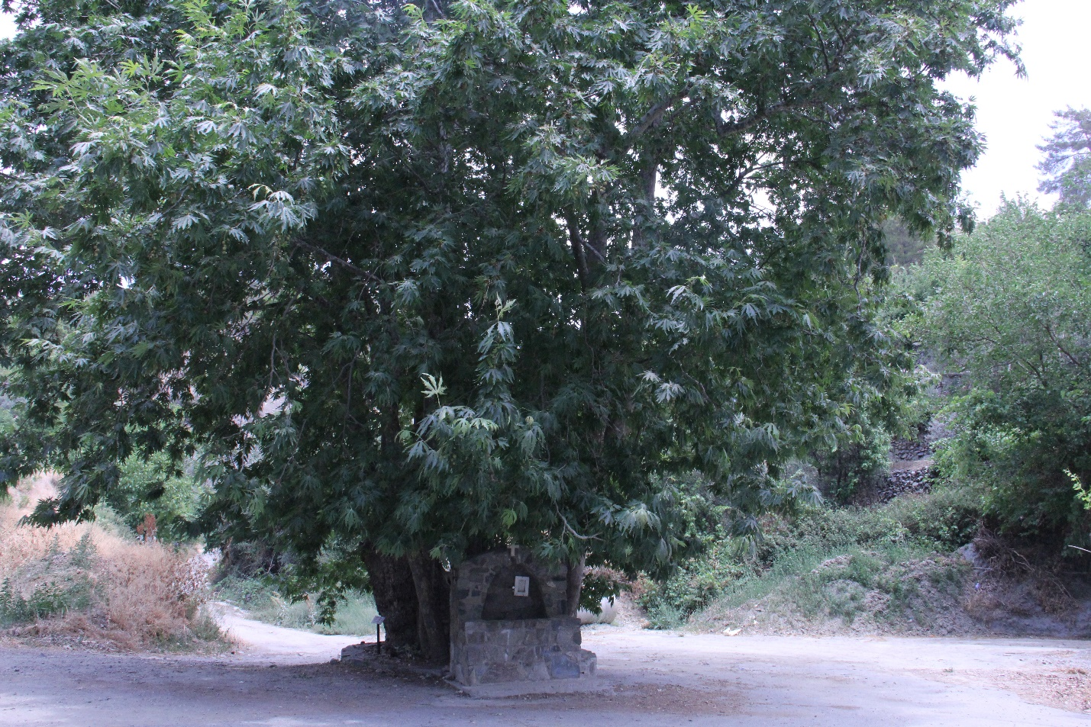

From here, follow the local hiking signs until arrows point you off the hiking trail. Follow the jeep track around the back of a private house (they are very friendly and are ready to cheer runners on) and onto a jeep track that leads down to a park next to the tarmac road towards Agros.
Turn right at the park and follow the road into Agros for about 800 metres. At the square, take the concrete pathway heading past the water fountain (pictured below).
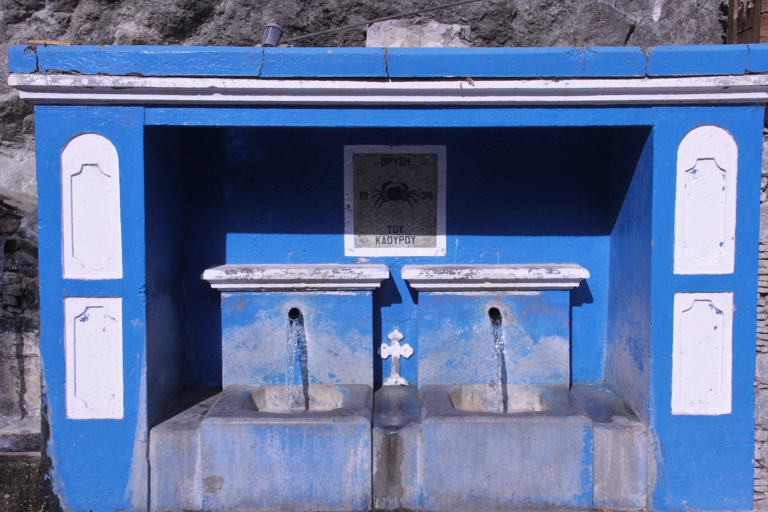

A tricky part of the route – follow the arrows and markings onto the trail that leads up to the reservoir. Go past the reservoir, alongside the grapevines and olive trees and up a path that leads onto the tarmac road. Head on the road back in the direction of the reservoir for about 150 metres. Look for the trailhead on your left. Follow the trail and jeep tracks until you rejoin the tarmac road (after about 2.5km). Soon afterwards the route will leave the tarmac and follow a rather tricky trail that starts alongside a grape vine and ends at the Cyta tower.
From the Cyta tower, take the Teisia tis Madaris trail that leads to the Madari fire lookout post (picture below)
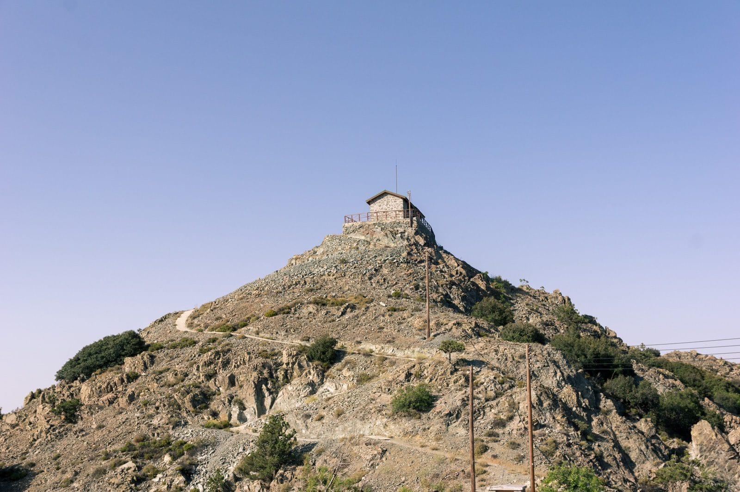
No need to go up to the lookout unless you specially would like to drink in the stunning views.
From here, go left (up the hill – not down into the valley) along the Doxa si o Theos trail for about 2.5km. Watch for the ‘Adventure Mountain Park’ sign pointing you onto a track that veers off to the left. Follow this track to the top section of the Adventure Mountain Park (pictured below) and the next major checkpoint/feeding station.
Runners must LEAVE this station by 2am on Sunday, Sept 11.
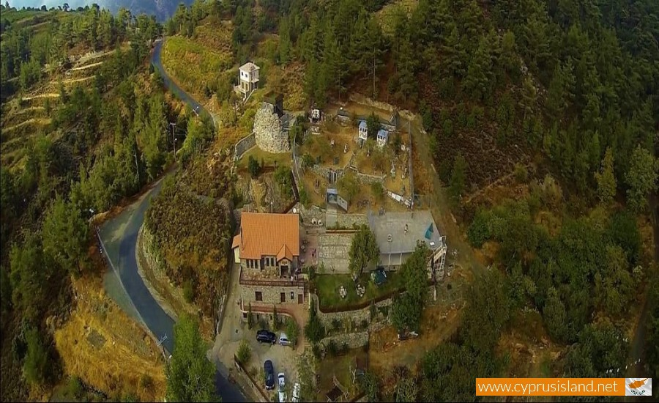

SECTION 5
Adventure Mountain Park to the finish line
25km elevation gain: 1122m
The first 6km of this section is relatively easy-going, and there are even some downhill sections! Follow the E4 hiking trail – look for the E4 signs as well as the Sea-to-Sky markings and arrows. The trail leads through the Moufflon enclosure and if you are lucky, you may see some of these beautiful mountain goats. If the gate is bolted (which it tends to be at night), simply slide the bolt and continue down the hill following the official track. Leave the Moufflon enclosure, cross the tarmac road and head to the entrance of the Platania picnic area (photo below)
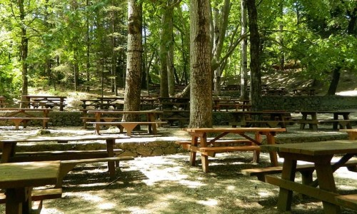
Fill up with water at the tap and follow the Sea to Sky and E4 signs through the picnic area, past the fire station and finally up onto one of the toughest sections of the route – the E4 from Platania to the Mnimata ton Piskipon trail.
The going is steep, rocky, energy-sapping, and unrelenting (picture below).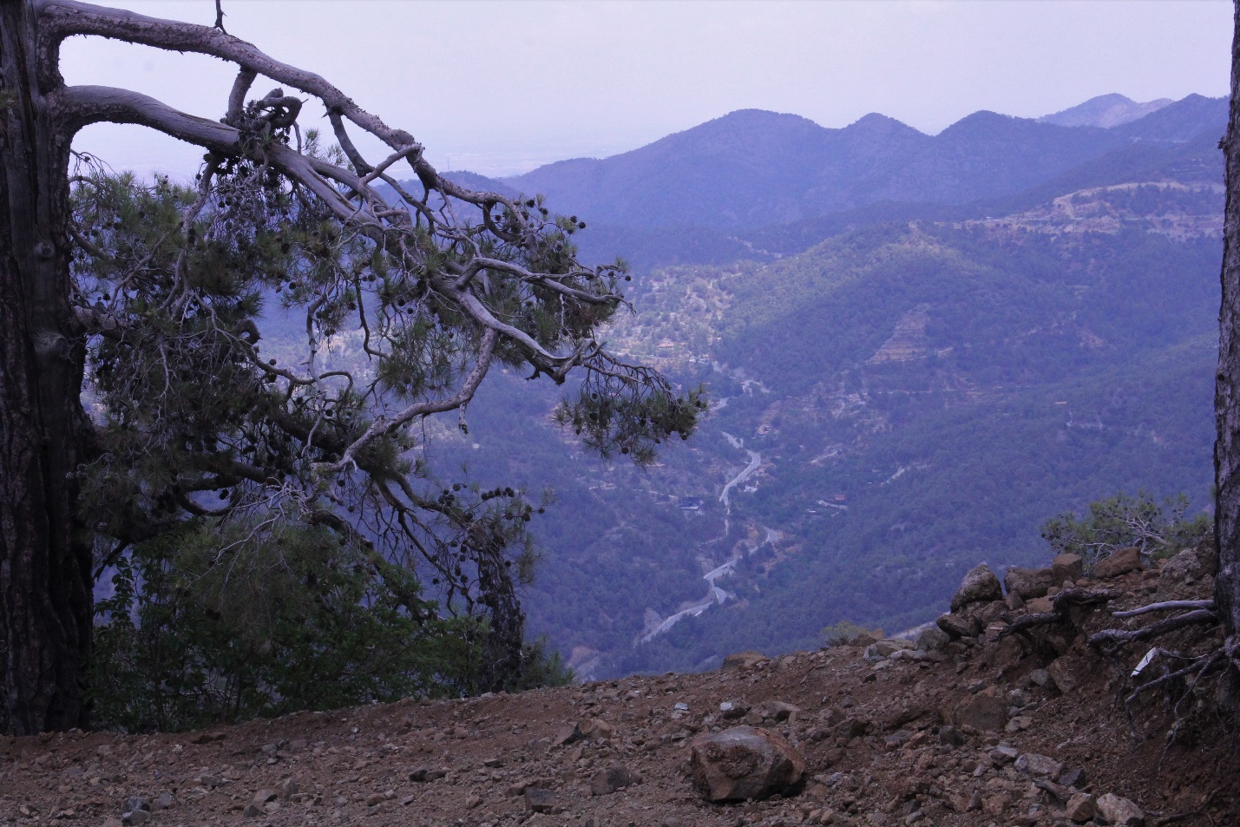
Once the E4 joins the Mnimata ton Piksipon trail, the going gets easier. Follow the wide jeep track – and the E4 signs -- all the way up the tarmac road.
Turn right and go down the hill. At the junction of the main road, turn right towards Troodos. After 300 metres you will find a well-stocked aid station next to a water fountain.
From the aid station, continue towards Troodos for about 1km. At the army camp, look for the arrows turning you off the tarmac road onto a jeep track. Follow this track upwards for about 2.5km, when it becomes part of the Atalante hiking trail. Follow the hiking trail for about 2.5km – take the left junction at the first intersection and the trail off to the right about 1km after that.
The trail ends at a jeep track. Go left and follow the track to the Ski Lift DIY water station station (water and Coke). You are now just 6km from the finish line.
Head through the trees UPHILL until you meet the Artemis trail (do not follow the trail that leads from the DIY station – that is the Atalante trail. You need to go up the hill to the Artemis trail. When you hit the Artemis trail and turn right. Follow the trail for about 2km until you see an arrow pointing you left off the Artemis onto a wider track filled with pinecones. Follow this all the way up the hill to the tarmac road. Cross over the road and follow the track that leads to the Olympus peak.
At the top of Olympus you will realise that you are indeed ‘touching’ the sky.
You can now sniff the finish line. It is just 2.5km away – and it’s downhill all the way.
Follow the tape and arrows all the way to the Jubilee hotel and the finish line. You have done it. You have conquered the Sea to Sky Cyprus.
Congratulations!!

